Conedexen Practice Problems

## Color Requirements:

1. Background: #FFF
2. Menu Bar Color: #F5F5F5
   1. Menu Bar Items Color: Black
3. Search Textbox Color: #FFF
   1. Search Word Color: Black
4. Search Button Color: #F7D145
5. Section Header Color: #dddddd
   1. Section Name Color: Black
6. Link Color: #207CC1
7. The rest of the document is based off the same colors.

Company Logo Link: <http://www.rccd.edu/community/cboc/PublishingImages/letterC.jpg>

Company Name: Conedexen || Font: Lucida Sans || Size: 24

Functionality:

1. Home Page:
   1. The tabs at the top must take the user to the next page. If they click on courses then a list of all the courses should show up on the second page. The same will happen with the conferences and books, except that this will be a list of conferences and books respectively.
   2. The huge image on the first page is a tabbed picture. The pictures will keep rotating in a sequence. If the viewer clicks on the tabs, then those tabs’ respective conference picture will be available. In addition, if the image itself is clicked on then the user should be taken to the next page, where they can see the details about the conference.
   3. In addition, the viewer must be able to search for a particular book or conference.
   4. Show the top 8 books in the bottom right section. If a viewer clicks on the image of any of these books then they should be able to go to the second page, in which there will be the details of the books.
   5. In the section on the bottom right, ensure that a few of the courses and conferences show up there. There should be around 6 of them. If they click on any of these individually then they should be able to go to the second page on which they will see the conference or course specifics.
2. The second page
   1. This page’s content will be dynamically loaded based upon what button or image is clicked on in the home page.
   2. If the anything from the menu on the tab is clicked then there should be a complete list of the respective category that was chosen. So if conferences was chosen then show a list with all the conferences.
   3. If an individual book, course or conference is chosen on the previous page, then make sure that only that things specific details loads and not the whole list.
   4. The mockup below, will show you what should show up when a particular book is clicked upon or chosen in the first page.
3. JSON file:
   1. A JSON File with all the data, URL’s and images will be provided to you.



# Mockup View:

## Main Page:

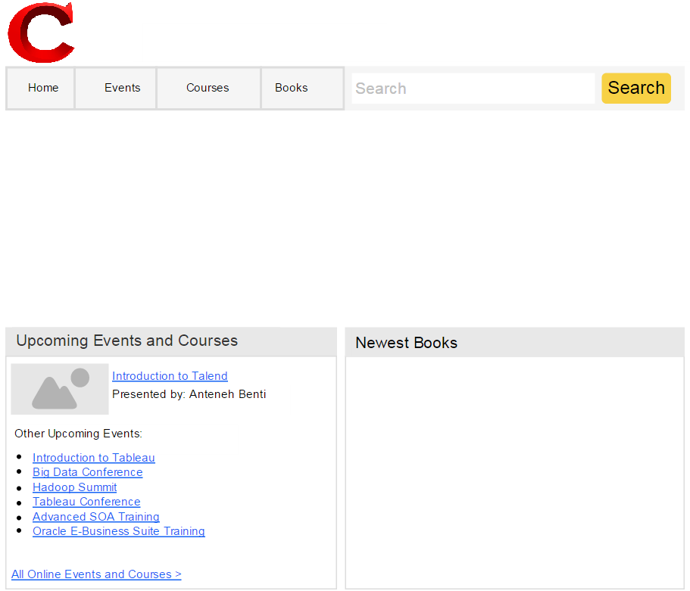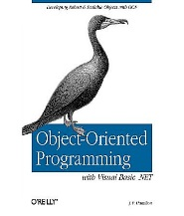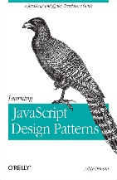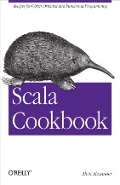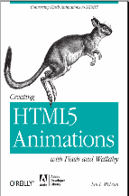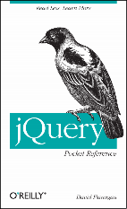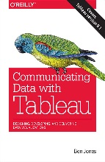

Conedexen



## Page 2 Version 1:

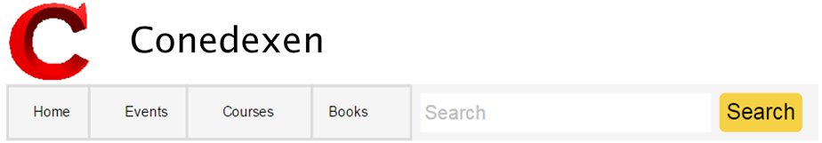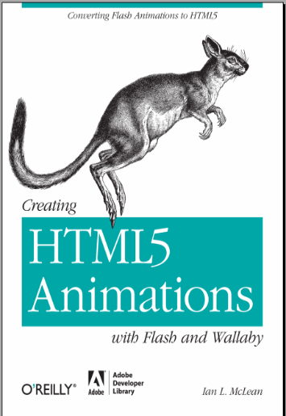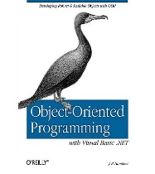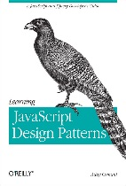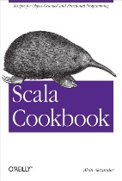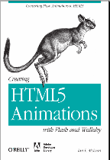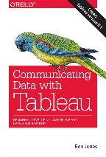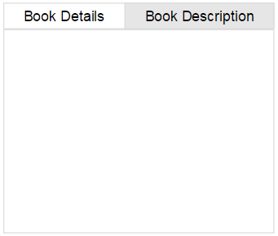

HTML 5 Animations

*Converting Flash Animations to HTML5*

**Author**: Ian L. McLean

**Publisher**: O’Reilly Media

**ISBN:** 978-1-4493-0713-4

**Pages**: 64

**Price:** $19.99